A1376-Eur-France-Neanderthal Hand Axe-Le Grand Pressigny Flint-Mousterian Bifacial Techno Complex, MBT-50,000 BP

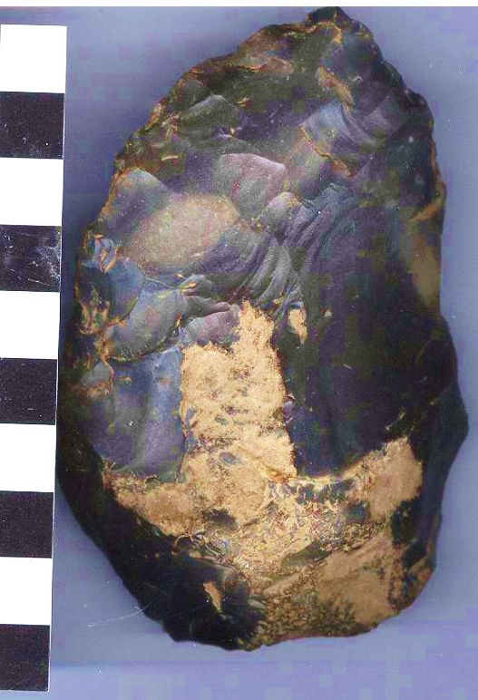

Fig. 1, Eur-France-Neanderthal Hand Axe-Le Grand Pressigny Flint-Mousterian Bifacial Techno Complex, MBT-50,000 BP

**Case no.: 1**

**Accession Number: A1376**

**Formal Label:** Eur-France-Neanderthal Hand Axe-Le Grand Pressigny Flint-Mousterian Bifacial Techno Complex, MBT-50,000 BP

**Display Description:**

This bifacial hand-axe is of the Mousterian Bifacial Techno Complex, MBT-50,000 BP and was knapped from Le Grand Pressigny Flint which was about 124 km south of the find spot indicating that the Neanderthal flint-knapper transported the raw material over 100 km north, which suggests “forward thinking”. **The form and execution of this extraordinary hand-axe was fashioned in the classic Mousterian Techno-Complex technique.  Mousterian hand-axes are smaller than the earlier and larger Sahara Acheulian hand-axes.  Mousterian hand-axes like this flawlessly executed bifacial example are considered some of the rarest and most prized Neanderthal lithics.  A prominent proximal end-knapped base has been knapped to rest against the palm of the hand for comfort.  The entire surface features a distinctive soil-sheen patina.  Superb shaping and delicate secondary flaking over faces and edges complete its execution.**

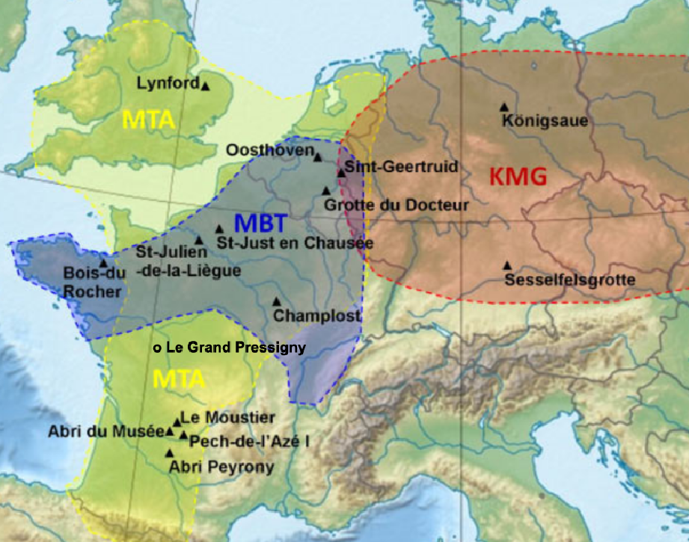

Location of the study sites and the three European Neanderthal cultures: Mousterian of Acheulean Techno-Complex, MTA; *Keilmessergruppen* (wedge blade [techno-complex] groups), KMG; and Mousterian Bifacial Techno-Complex, MBT (map after Karen Ruebens).

**GPS coordinates:**

**Cultural Affiliation:** Mousterian Bifacial Techno-Complex, MBT-50,000 BP

**Medium:** Le Grand Pressigny flint

**Dimensions:**

**Weight:**

**Condition: original**

**Provenance:** some 124 km north of Le Grand Pressigny site.

**Discussion:**

Karen Ruebens of the University of Southampton reported (Ruebens 2013) on a study **of 1,300 stone hand axes found at 80 Neanderthal sites in France, Germany, Belgium, Britain and the Netherlands. She shows that three** discrete hand axe techno complexes existed – the Mousterian Acheulean Techno-Complex (MTA) in a region now spanning south-western France and Britain, the *Keilmessergruppen* [Techno-Complex] (KMG) in Germany and further to the East **between 115,000 to 35,000 BP, and the** Mousterian Bifacial Techno-Complex, MBT-50,000 BP between the KMG and the MTA. She also identified an area covering modern day Belgium and the Netherlands that demonstrates a transition between the two.“In Germany and France there appears to be two separate hand axe traditions, with clear boundaries, indicating completely separate, independent developments.” “The transition zone in Belgium and Northern France indicates contact between the different groups of Neanderthals, which is generally difficult to identify but has been much talked about, especially in relation to later contacts with groups of modern humans.”“This area can be seen as a melting pot of ideas where mobile groups of Neanderthals, both from the eastern and western tradition, would pass by – influencing each other’s designs and leaving behind a more varied record of bifacial tools.”Neanderthals in the western region made symmetrical, triangular and heart-shaped hand axes, while during the same time period, in the eastern region, they produced asymmetrically shaped bifacial knives.

[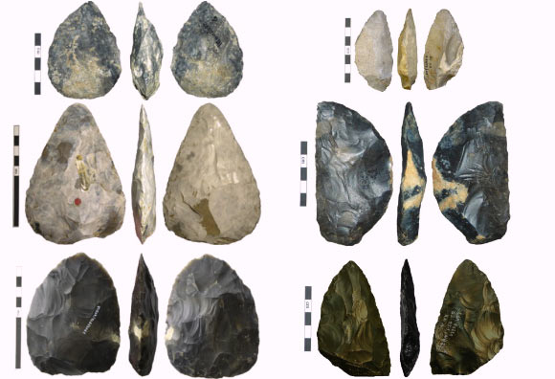](http://cdn.sci-news.com/images/enlarge/image_1322_2e-Neanderthals.jpg)

Left: Mousterian of Acheulean Tradition (MTA) hand axes, from top to bottom – cordiform hand axe from Le Moustier, France; triangular hand axe from St. Just en Chaussée, France; hand axe from Lynford, UK (Karen Ruebens). Right: Keilmessergruppen Tradition (KMT) hand axes, from top to bottom – KMT from Sesselfesgrotte, Germany; KMT from Abri du Musée, France; fist-shaped KMT from Königsaue, Germany (Karen Ruebens).

Karen Ruebens elaborates on her discovery of the conservative nature of Neanderthal lithic manufacture that also has implications about Neanderthal cognitive development and symbolic expression: “Distinct ways of making a hand axe were passed on from generation to generation and for long enough to become visible in the archaeological record. This indicates a strong mechanism of social learning within these two groups [MTA and KMT] and says something about the stability and connectivity of the Neanderthal populations.” “Making stone tools was not merely an opportunistic task. A lot of time, effort and tradition were invested and these tools carry a certain amount of socio-cultural information, which does not contribute directly to their function.” Ruebens has developed a convincing case for Neanderthal regionality suggesting various factors such as raw material availability and the function of sites implying forward thinking (contra L.R. and S.R. Binford 1966), and reuse and retouching of tools implying a sense of environmental sustainability reducing the need to make extensive return trips to the lithic material source. Ruebens’ studies (listed below) not only add a discrete lithic perspective to Neanderthal regionality that supports previous studies of Neanderthal taphonomies, and skeletal and genetic findings, but also adds new dimensions to Neanderthal discrete regional symbolic behaviors and symbolic expressions in the technical production of lithics.

______

**References:**

Binford, L.R. and Binford, S.R., 1966. The predatory revolution: a consideration of the evidence for a new subsistence level. *American Anthropologist*, *68*(2), pp.508-512.

Ruebens, K., 2014. Late Middle Palaeolithic bifacial technologies across northwest Europe: Typo-technological variability and trends. *Quaternary International*, *350*, pp.130-146.

Ruebens, Karen. 2013. Regional behaviour among late Neanderthal groups in Western Europe: A comparative assessment of late Middle Palaeolithic bifacial tool variability. *Journal of Human Evolution*, published online August 6, 2013; doi: 10.1016/j.jhevol.2013.06.009

Ruebens, K., 2012. From Keilmesser to Bout Coupé Handaxes: Macro-Regional Variability among Western European Late Middle Palaeolithic Bifacial Tools. *University of Southampton*, p.381.

Ruebens, K., 2007. Bifacial elements in continental northwestern Europe during the last glacial cycle (MIS5d-3): the relationship between Mousterian, Micoquian and ‘mixed’assemblages. *Papers from the Institute of Archaeology*, *18*, pp.84-103.

Ruebens, K., 2006. The Middle Palaeolithic assemblage of Oosthoven (Belgium): a techno-typological and comparative analysis. *Terra Incognita. Annual Review of Archaeological Master Research in Flanders*, *1*, pp.187-199.

Ruebens, K. and Sykes, R.M.W., 2016. Spatio-temporal variation in late Middle Palaeolithic Neanderthal behaviour: British bout coupé handaxes as a case study. *Quaternary International*, *411*, pp.305-326.

Pope, M., Bates, M., Cole, J., Conneller, C., Ruebens, K., Scott, B., Shaw, A., Smith, G., Underhill, D. and Wragg-Sykes, R., 2012. Quaternary Environments and Archaeology of Jersey: A new multidisciplinary project looking at the early prehistoric occupation of the English Channel Region. *Unravelling the Palaeolithic*, *10*, p.27e38.